**CENG 342 - Homework 3 Report**

Matrix 1 Results:

|  |  |  |  |
| --- | --- | --- | --- |
| **Number of Cores** | **Elapsed Time(s)** | **Speed-Up (S=Tserial/Tparallel)** | **Efficiency (E=Tserial/p*Tparallel)** |
| 1 | 0.033 | 1 | 1 |
| 2 | 0.029 | 1.138 | 0.569 |
| 3 | 0.036 | 0.917 | 0.306 |
| 4 | 0.032 | 1.031 | 0.258 |

Matrix 2 Results:

|  |  |  |  |
| --- | --- | --- | --- |
| **Number of Cores** | **Elapsed Time(s)** | **Speed-Up** | **Efficiency** |
| 1 | 0.001 | 1 | 1 |
| 2 | 0.001 | 1 | 0.500 |
| 3 | 0.001 | 1 | 0.333 |
| 4 | 0.001 | 1 | 0.250 |

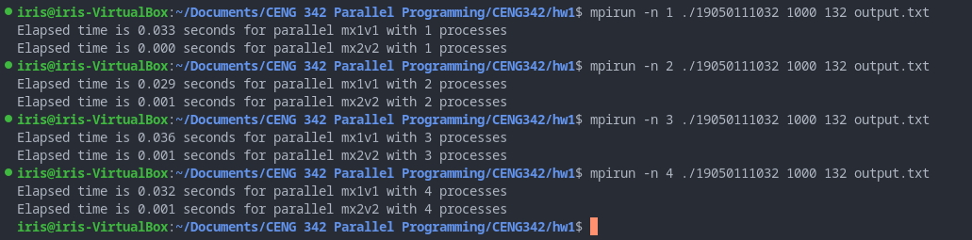

Since I got a error with a 1032x1032 dimensional array, I used smaller matrix in this homework.

